Lesson 4 Demo 3: Rollout Status Check

This section will guide you to:

* Check the rollout status

This lab has one sub-section, namely:

1. Checking the rollout status

**Note:** If you don’t have an existing Kubernetes cluster, refer to the Demo 1.1 of Lesson 1.

**Step 1:** Checking the rollout status

* Start the kubernetes cluster in the lab
* Create the following yaml file:

*cat > nginx-deployment.yaml*

apiVersion: apps/v1

kind: Deployment

metadata:

name: nginx-deployment

labels:

app: nginx

spec:

replicas: 3

selector:

matchLabels:

app: nginx

template:

metadata:

labels:

app: nginx

spec:

containers:

- name: nginx

image: nginx:1.7.9

ports:

- containerPort: 80  
  
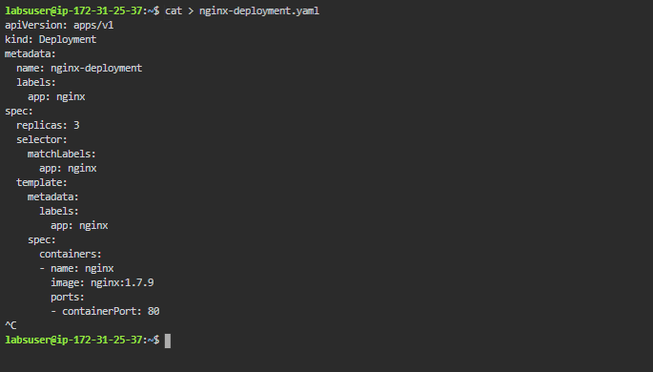

* Next, create the deployment by running the kubectl command **kubectl apply -f nginx-deployment.yaml** as shown below:

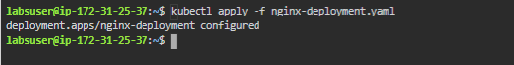

* Run **kubectl get deployments** to check if the deployment was created. If the deployment is still being created, the output will look like the one shown below:

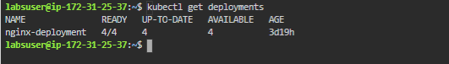

* Now, to see the deployment rollout status, run the **kubectl rollout status deployment.v1.apps/nginx-deployment**. The output should be like the one shown below:



* Sometimes, you may want to rollback a deployment  
  **For example**: When the deployment is not stable, such as crash looping
* Suppose you have made a typo while updating the deployment, by putting the image name as nginx:1.91 instead of nginx:1.9.1, the output will be like the one shown below:  
    
  *kubectl set image deployment.v1.apps/nginx-deployment nginx=nginx:1.91 --record=true*



* So, now you can check the rollout history as shown below:  
    
  *kubectl rollout history deployment.v1.apps/nginx-deployment*

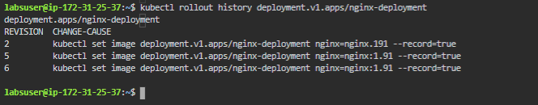

* This is how we can update the deployment rollout using kubectl commands